1. Write a PHP program to enter marks of five subjects Physics, Chemistry, Biology, Mathematics and Computer, calculate percentage and grade by if else

<?php

$physics = 90;

$chemistry = 80;

$biology = 70;

$mathematics = 60;

$computer = 50;

$total = NULL;

$grade = NULL;

$total = $physics+$chemistry+$biology+$mathematics+$computer;

$percentage =($total/500.0)\*100;

if($percentage>=90)

$grade ="A";

else if($percentage>=80 && $percentage<90)

$grade ="B";

else if($percentage>=70 && $percentage<80)

$grade ="C";

else if($percentage>=60 && $percentage<70)

$grade ="D";

else

$grade = "E";

echo "The percentage :".$percentage."<br>";

echo "The grade :".$grade;

?>

Output:

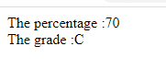

1. write a PHP program for find „Thursday‟ in week using switch Function.

<?php

$day = "4";

switch ($day) {

case "1":

echo "It is Monday!";

break;

case "2":

echo "It is Tuesday!";

break;

case "3":

echo "It is Wednesday!";

break;

case "4":

echo "It is Thursday!";

break;

case "5":

echo "It is Friday!";

break;

case "6":

echo "It is Saturday!";

break;

case "7":

echo "It is Sunday!";

break;

default:

echo "Invalid number!";

}

?>

Output:



1. Write a PHP program to check Leap years between 1901 to 2016 Using nested if.

<?php

for($year=1901; $year<=2016; $year++)

{

if($year %4==0)

echo "$year is a Leap Year.";

else

echo "$year is not a Leap Year.";

}

?>

OUTPUT:

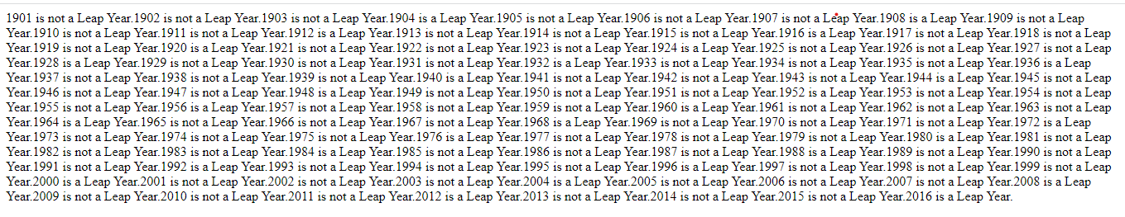

1. Write a PHP program to find the largest of three numbers using ternary Operator.

<?php

$x= 15;

$y= 20;

$z= 25;

{

$max = ($x > $y)? (($x > $z)? $x : $z) : (($y > $z)? $y : $z);

echo "Largest number among $x, $y and $z is: $max\n";

}

Output:



1. Write a program in PHP to print Fibonacci series. 0, 1, 1, 2, 3, 5, 8, 13, 21,

34

<?php

$num = 0;

$n1 = 0;

$n2 = 1;

echo "Fibonacci series for first 10 numbers:";

echo $n1.' '.$n2.' ';

while ($num < 8 )

{

$n3 = $n2 + $n1;

echo $n3.' ';

$n1 = $n2;

$n2 = $n3;

$num = $num + 1;

}

?>

Output:



1. Write a program to find whether a number is Armstrong or not
2. Write a program to print the below format :

5 9

2610

3711

4812

1. Write a program for this Pattern:

\*\*\*\*\*

\*

\*

\*

\*\*\*\*\*

<?php

for($i=1; $i<=5; $i++)

{

for($j=1; $j<=5; $j++)

{

if($i==1||$i==5||$j==1)

{

echo "\*";

}

}

echo "<br>";

}

?>

Output:



1. What will be the values of $a and $b after the code below is executed? Explain your answer.

$a = '1';

$b = &$a;

$b = "2$b";

1. How can you tell if a number is even or odd without using any Condition or loop?
2. How can you declare the array (all type) in PHP? Explain with example Covert a JSON string to array.